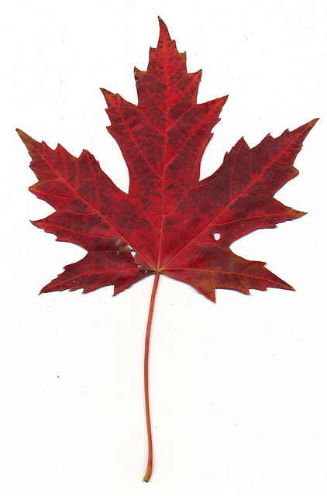

# KINGSTONE AND THRUXTON GROUP PARISH COUNCIL



**Parish Councillors are summoned**

**to attend the next Parish Council Meeting**

**on**

**Wednesday 2nd February 2022**

**starting at 7.00p.m.**

**This meeting will be held in the Village Hall**

***As always, press and all residents are cordially invited to attend.***

|  |
| --- |
|  |